PCB Design & Manufacturing Document

Digital Thermometer Project

1. Introduction
A digital thermometer is an electronic device used to measure temperature accurately and display it in digital form. This project focuses on the design and manufacturing of a Printed Circuit Board (PCB) for a digital thermometer using basic electronic components and a microcontroller.
The aim of this document is to explain the PCB design process, component selection, circuit operation, and manufacturing steps in a simple and systematic manner suitable for academic projects.

2. Project Objectives
- To design a compact and reliable PCB for a digital thermometer
- To understand PCB layout and manufacturing steps
- To interface a temperature sensor with a microcontroller
- To display temperature digitally

3. Block Diagram
Temperature Sensor → Microcontroller → Display → Power Supply

4. Components Used
S.No | Component | Specification | Quantity
1 | Microcontroller | Arduino Nano / ATmega328 | 1
2 | Temperature Sensor | LM35 / DS18B20 | 1
3 | Display | 16x2 LCD / OLED | 1
4 | Resistors | 10kΩ, 220Ω | As required
5 | Capacitors | 0.1µF, 10µF | As required
6 | PCB | Single-layer FR4 | 1
7 | Power Supply | 5V DC | 1

5. Circuit Description
The temperature sensor senses the surrounding temperature and converts it into an electrical signal. This signal is fed into the microcontroller. The microcontroller processes the data and calculates the temperature value, which is then displayed on the digital display.
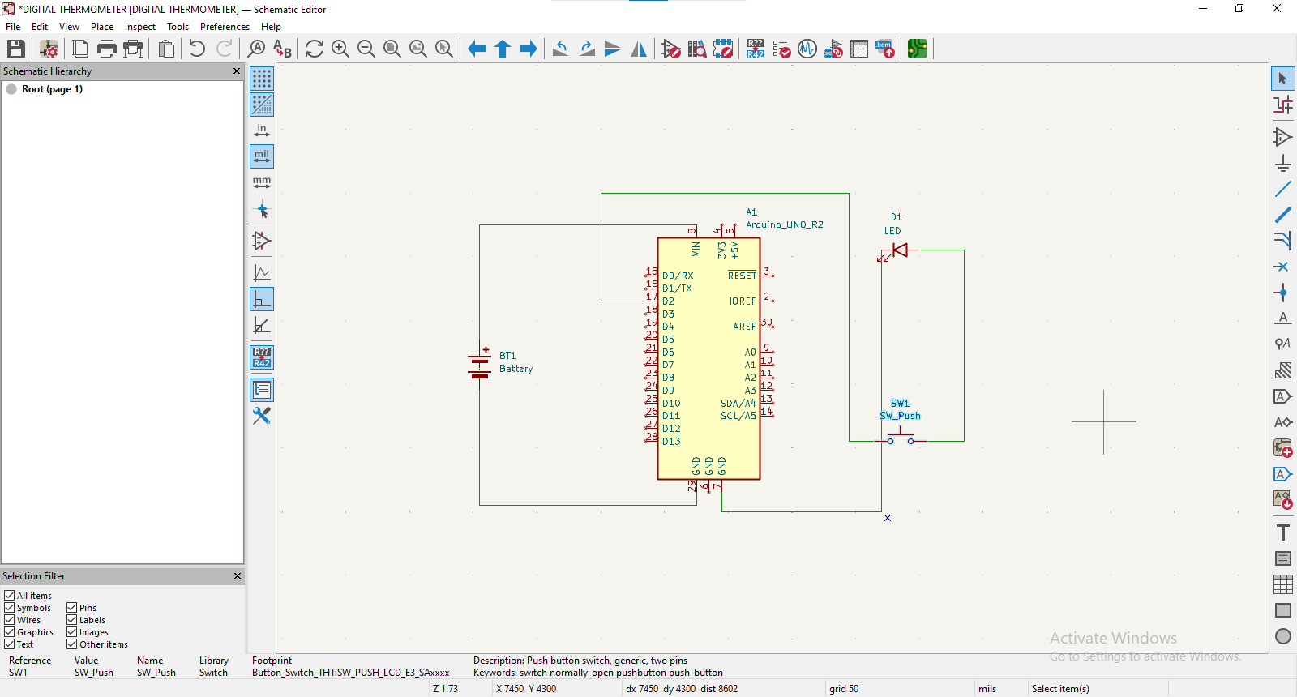

6. PCB Design Process

6.1 Schematic Design
- Draw the circuit schematic using PCB design software such as EasyEDA, Proteus, or KiCad
- Verify all component connections

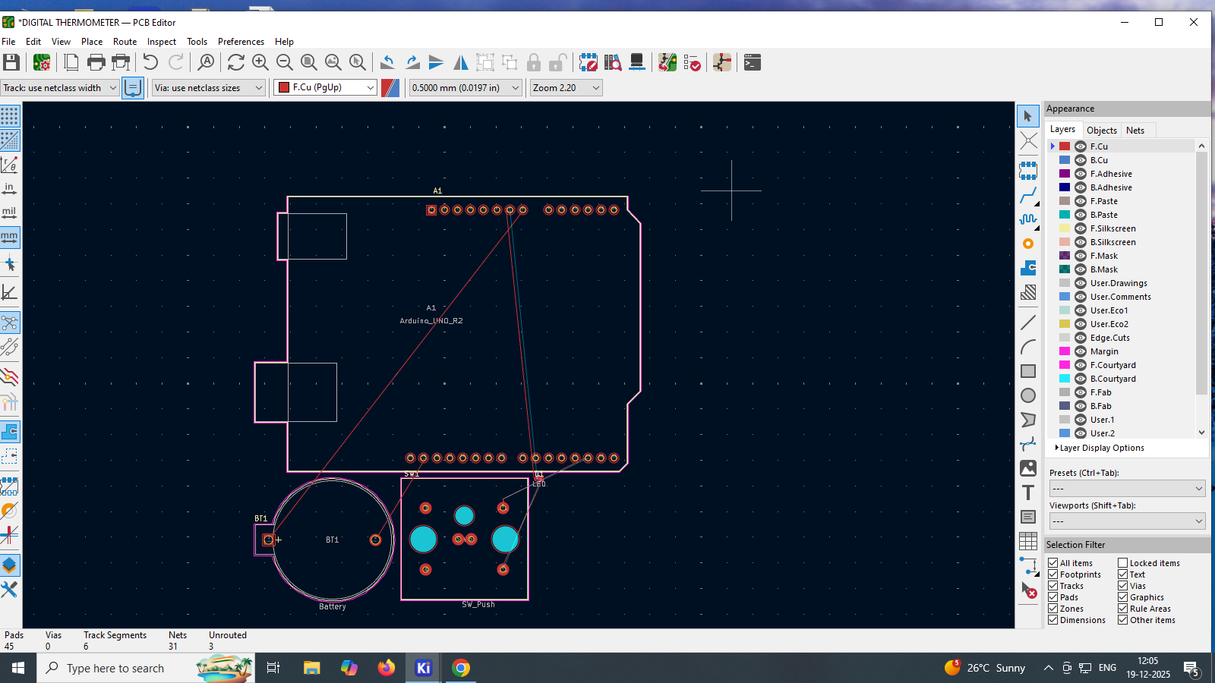

6.2 PCB Layout Design
- Convert schematic to PCB layout
- Place components efficiently to reduce track length
- Use proper track width for power and signal lines
- Add ground plane if required

6.3 Design Rule Check (DRC)
- Ensure no short circuits
- Maintain proper clearance between tracks

7. PCB Manufacturing Process

7.1 Printing
- Print the PCB layout on glossy paper or transparency

7.2 Etching
- Transfer layout onto copper-clad board
- Use etching solution to remove unwanted copper

7.3 Drilling
- Drill holes for component leads

7.4 Soldering
- Mount components on PCB
- Solder carefully to avoid shorts

- 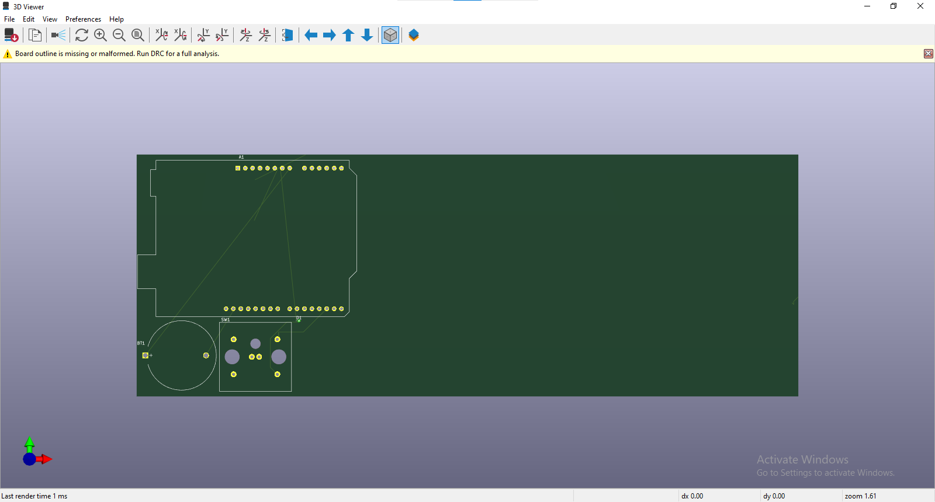

8. Testing and Calibration
- Power the circuit with 5V supply
- Compare displayed temperature with a reference thermometer
- Adjust code if calibration is required

9. Applications
- Medical thermometers
- Weather monitoring systems
- Industrial temperature monitoring
- Home automation

10. Advantages
- High accuracy
- Compact design
- Low power consumption
- Easy to use

